|  |  |
| --- | --- |
| Stella Nova Logo | LOGO4 |
| Best Buy Canada Mobile | |
| |  | | --- | | **Layaway Pre-Order Tender Feature Document** |   **Document Version: 1.1**  **Design Date: October 23, 2013** | |
| **Prepared By: Amy Lackas** | |
|  | |

**Table of Contents**

*1.* *Feature Overview* 3

1.1 Feature Description 3

1.2 Assumptions 3

1.3 Parameters and System Settings 3

1.4 Interfaces 3

*2.* *USE CASE: Layaway/Pre-Order Tender* 3

2.1 Feature Flow 3

2.2 Precondition 3

2.3 Main Flow 3

2.4 Alternate Flows 4

2.5 Post Condition 4

2.6 Special Requirements 4

*3.* *Supplemental Specifications* 4

3.1 Electronic Journal 4

3.2 POSLog 4

3.3 Printed Receipts 4

3.4 Tender Feature 4

3.5 Training Mode Feature 4

*4.* *Screen Layouts* 5

4.1 Enter Transaction Key 5

*5.* *Business Sign Off* 7

*6.* *Revision History* 7

*7.* *Appendix A: Glossary* 7

*8.* *Appendix B: Receipt Example* 7

8.1 Layaway/Pre-Order Tender 7

*9.* *Appendix C: POSLog Example* 8

9.1 Layaway/Pre-Order Tender 8

*10.* *Appendix D: EJ Example* 8

10.1 Layaway/Pre-Order Tender 8

# *Feature Overview*

## Feature Description

Companies can be setup with accounts that can be used when making purchases at the retailer.

## Assumptions

1. All text displayed by the system is configurable by brand to support multi-language.  Text is defined from an external source or defined within the system.
2. Minimum amount for all tenders is $0.01.
3. Maximum amount for all tenders is $99,999.99.

## Parameters and System Settings

|  |  |  |
| --- | --- | --- |
| **Parameter Mnemonic** | **Description** | **Valid Values** |
| Layaway Pre-Order House Account Number | Determines the house account number to apply to the Layaway/Pre-Order Tender | * House Account Number |

## Interfaces

|  |  |
| --- | --- |
| **Interface** | **Description** |
| Payment Authorization Service | Payment Authorization service that manages the processing of certain types of cards (Debit, EMV) and authorizes the tender amount to apply to the card. |

# *USE CASE: Layaway/Pre-Order Tender*

## Feature Flow



## Precondition

* Layaway/Pre-Order tender has been selected.

## Main Flow

1. They system executes the Capture Transaction Key alternate flow.
2. The system calls the authorizing service with the layaway/preorder account details.
3. The system displays a message indicating authorization or deactivation is in progress.
4. The system receives an authorized decision.
5. If the authorization decision is Declined, Offline or Timeout, the Declined Authorization Decision alternate flow is executed.
6. If the authorized decision is Approved, the system evaluates the amount returned in the response.
7. If the amount returned is less than or equal to the transaction balance, the system adds the tender to the transaction for amount returned and updates the Balance Due amount.
8. If the amount returned is greater than the transaction balance, then the system displays the available tenders to refund balance.
9. The system journals and logs the house account, authorization details.
10. The use case ends and the system returns to the Tender use case.

## Alternate Flows

### Declined Authorization Decision

1. The system journals the authorization decision.
2. The system displays a message, the operator acknowledges the message, the use case ends and the system returns to the Tender use case without adding the tender.

## Post Condition

* Layaway/Pre-Order tender is added to the transaction.

## Special Requirements

1. The system uses the authorization amount returned in the response not any value entered at the start of selecting the tender.

### Special Offline Requirements

TBD

### Data Input/Output

|  |  |  |
| --- | --- | --- |
| **Data Element** | **Description** | **Destination** |
|  |  |  |

# *Supplemental Specifications*

## Electronic Journal

Electronic journal mockups for this feature are documented in the Electronic Journal document.

## POSLog

POSLog mockups for this feature are documented in the POSLog document.

## Printed Receipts

Printed receipt mockups, where applicable, are documented in the Receipt Generation document.

## Tender Feature

The Tender use case is updated to display Layaway/Pre-Order tender when available for the transaction type. The tender is eligible to be voided.

## Training Mode Feature

The Training Mode use case is updated to add the Layaway/Pre-Order feature to Training Mode with no authorization call executed and the authorization is returned approved.

# *Screen Layouts*

## Enter Transaction Key

The Enter Transaction Key screen is displayed when the operator selects to lookup previous transaction for finance plan and standalone warranty processes. The receipt barcode can be scanned on this screen.

**Note**: This is the same screen used during Lookup Previous Transaction Standalone PSP Sale and Lookup Finance Tender Transaction for Admin Fee process.

### Mockup

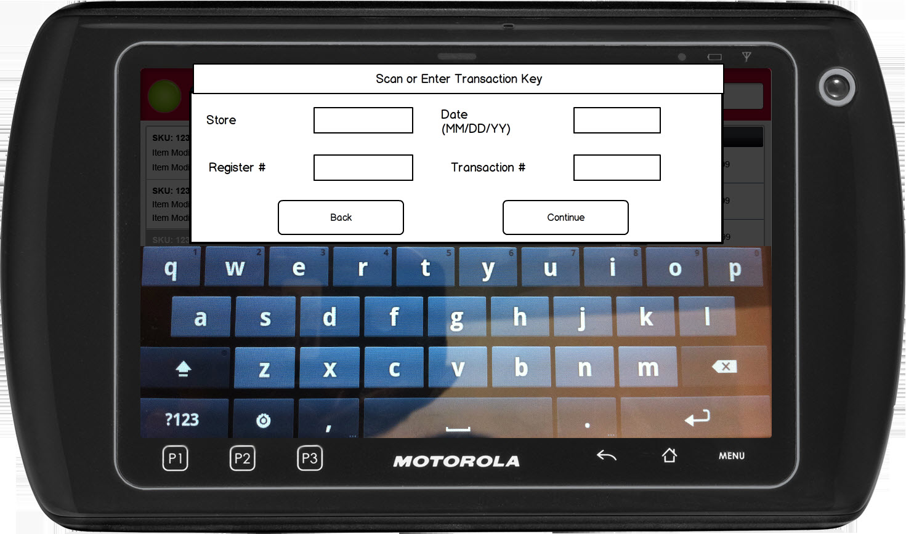

Figure 1: Enter Transaction Key

### Instruction Text

|  |
| --- |
| **Instructions** |
|  |

### Navigation/Menu Key

|  |  |  |  |
| --- | --- | --- | --- |
| **Label Text** | **State** | **Next Screen** | **Notes** |
| Back | Enabled | * Sale Use Case | None |
| Continue or Scan Receipt Barcode | See Notes | * Layaway/Pre-Order House Account Number requires additional customer information: Capture Additional Customer Information * Layaway/Pre-Order House Account Number does not require additional customer information: Authorization Service Call with House Account Information | No validation is completed against the entered Transaction Key. The Transaction Lookup service is not called, the system just collects the entered data and logs it and sends the transaction key in the authorization request when required. |

### Data/Input Field

|  |  |  |  |  |  |  |
| --- | --- | --- | --- | --- | --- | --- |
| **Label Text** | **Editable** | **Req’d?** | **Data Type** | **Min**  **Length** | **Max**  **Length** | **Notes** |
| Store | Yes | Yes | Numeric | 1 | 4 | None |
| Date | Yes | Yes | NA | NA | NA | None |
| Register # | Yes | Yes | Numeric | 1 | 4 | None |
| Transaction # | Yes | Yes | Numeric | 1 | 6 | None |

### Reason Code

|  |  |  |
| --- | --- | --- |
| **Reason Code** | **Valid Values** | **Default Value** |
| None |  |  |

# *Business Sign Off*

|  |  |  |
| --- | --- | --- |
| **Name** | **Organization** | **Date** |
| <Name of signer> | <Organization of signer if applicable> | <date of sign off> |

# *Revision History*

|  |  |  |  |
| --- | --- | --- | --- |
| **Reviser** | **Revision** | **Date** | **Version** |
| Amy Lackas | Initial document created | 10/23/2010 | 1.0 |
| Amy Byers | Remove custom house account prompts as not prompted for layaway/preorder tenders | 4/8/2014 | 1.1 |
| Amy Byers | * Section 2.3: Added accepting Layaway tender less than and greater than the transaction balance. * Section 2.6: Removed question on how to handle refunds from layaway deposit tender. * Section 7: Added Requirements Matrix | 10/6/2014 | 1.2 |

# Appendix : Source Documentation

* Requirement Specification - XPOS.xlsx

## Functional Requirements

| **ID** | **Sub Category** | **Description** | **Section(s)** |
| --- | --- | --- | --- |
| 5.2 | Layaway Deposit | Validation will be performed to ensure that the Layaway Deposit has not been previously redeemed. | * 2.3 Main Flow |
| 5.3 | Layaway Deposit | Should a user attempt to validate a layaway deposit for a value greater than it is worth, ~~XPOS will return a message indicating the value that may be redeemed,~~  XPOS will apply the actual redeemable value and then prompt for an additional form of tender. | * 2.3 Main Flow |
| 5.3.1 | Layaway Deposit | Should the transaction total less then the amount of the Layaway Deposit, the remainder will be cashed out and the user will select the return MOP. | * 2.3 Main Flow |
| 5.4 | Pre-Order | Pre-Orders will be accepted as a valid form of payment. | * 2.3 Main Flow |
| 5.5 | Pre-Order | Validation will be performed to ensure that the Pre-Order has not been previously redeemed. | * 2.3 Main Flow |
| 5.6 | Pre-Order | Should a user attempt to validate a Pre-Order for a value greater than it is worth, ~~XPOS will return a message indicating the value that may be redeemed~~, XPOS will apply the actual redeemable value and then prompt for an additional form of tender. | * 2.3 Main Flow |
| 5.6.1 | Pre-Order | Should the transaction total less then the amount of the Pre-Order, the remainder will be cashed out and the user will select the return MOP. | * 2.3 Main Flow |

# *Appendix : Glossary*

|  |  |
| --- | --- |
| **Term** | **Definition** |
|  |  |

# *Appendix B: Receipt Example*

## Layaway/Pre-Order Tender

|  |  |
| --- | --- |
| Welcome to Best Buy #998  Corp POS Lab, BC  (999) 999-9999  POS LAB TESTING    Val # 1234-2432-2344-2542  0980 001 0362 02/19/13 15:31 W735  10001000 Item Desc 199.99  Item long description  10001001 CA-3552 49.97  CYBER CA-3552  --------  SUBTOTAL 249.96  HST BC 30.00    TOTAL 279.96  Layaway Deposit 279.96  REF: 959 1 941 01/30/13 |  |
|  |  |

# *Appendix C: POSLog Example*

## Layaway/Pre-Order Tender

**LineItem – Tender**

The additional prompts including the transaction key collected during the tender process is logged in the POSLog

<LineItem EntryMethod=”Keyed”>

<LineNumber>5</LineNumber>

<Tender TenderType=”HouseAccount” TypeCode=”Sale”>

<TenderID>34</TenderID>

<UserTenderID>34</UserTenderID>

<Amount Currency=”CAD”>-279.96</Amount>

<Authorization HostAuthorized=”” ElectronicSignature=”false” EntryMethod=”Keyed”>

<AuthorizationCode AuthCodeSource=”E”>429593</AuthorizationCode>

</Authorization>

<StoreAccount>

<AccountNumber>0100</AccountNumber>

<TransactionLink ReasonCode=”LayAway”>

<RetailStoreID>959</RetailStoreID>

<WorkstationID>1<WorkstationID>

<RegisterTransactionNumber>941</RegisterTransactionNumber>

<BusinessDayDate>2013-01-30</BusinessDayDate>

</TransactionLink>

</StoreAccount>

</Tender>

</LineItem>

# *Appendix D: EJ Example*

## Layaway/Pre-Order Tender

…

SUBTOTAL $249.96

TAX 13.00% $30.00

TOTAL $279.96

House Account $279.96

Account Number: 0100

0959 001 0941 01/30/13

AUTHORIZATION: 429593

…